DIGITAL FORENSICS INVESTIGATION REPORT USING AUTOPSY

INTRODUCTION
Digital forensics is the process of identifying, preserving, analyzing, and presenting digital evidence in a manner that is legally acceptable. It is commonly used in investigations involving cybercrime, fraud, and unauthorized system access.

Autopsy is an open-source digital forensics tool used to analyze disk images and recover evidence such as deleted files, browsing history, and user activity. It provides investigators with a graphical interface to examine digital evidence efficiently.

This report presents a digital forensic investigation conducted using Autopsy. The objective was to analyze a disk image, recover deleted files, examine user activity, and generate a forensic report.

METHODOLOGY
The investigation followed standard digital forensic procedures:

Installation and Setup
    - Downloaded and installed Autopsy.
    - Launched the application.
    - Created a new case with relevant details such as case name and directory.
    - 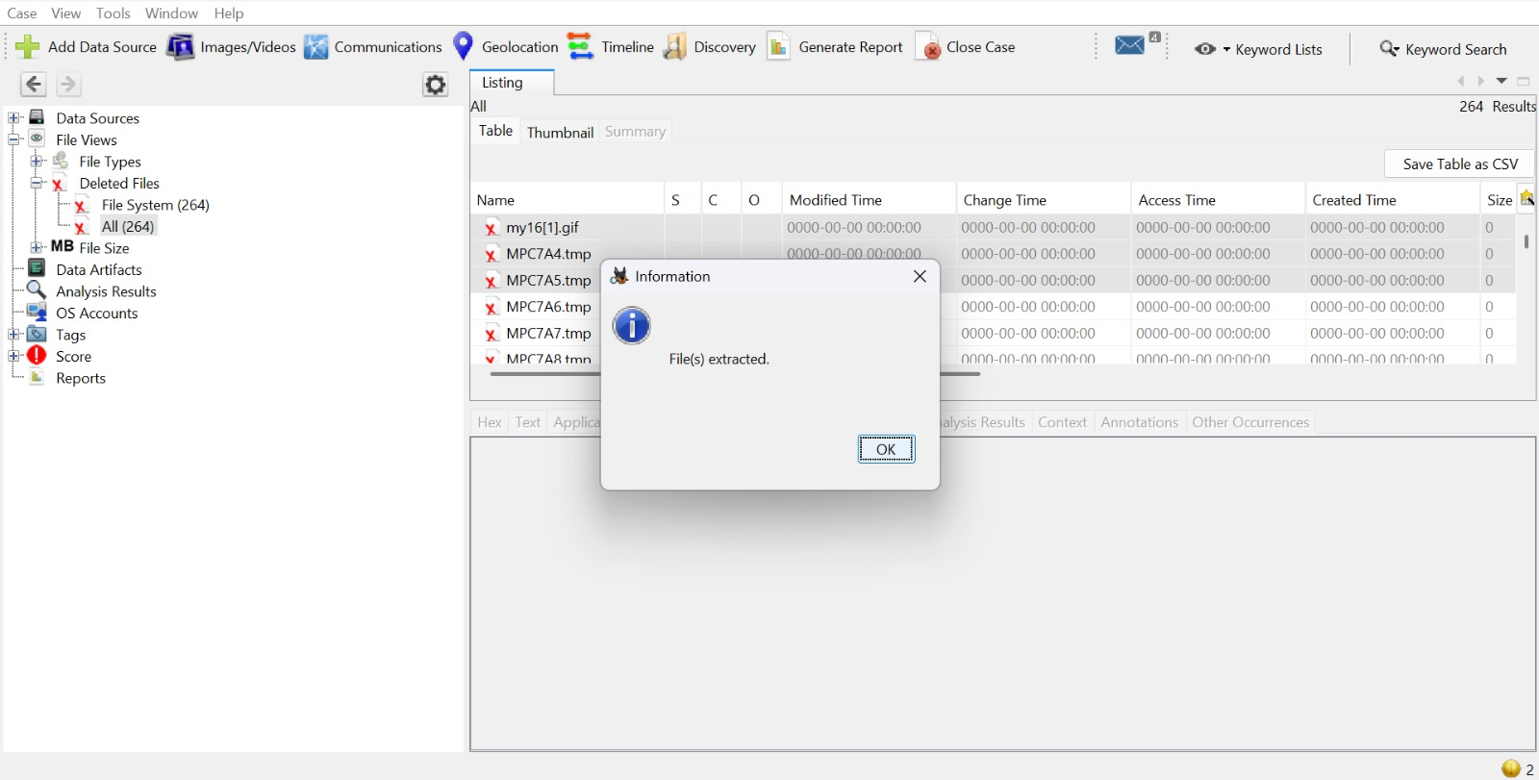

Case Creation and Evidence Loading
    - Created a new case in Autopsy.
    - Added a data source (disk image file such as .E01, .dd, or .img).
    - 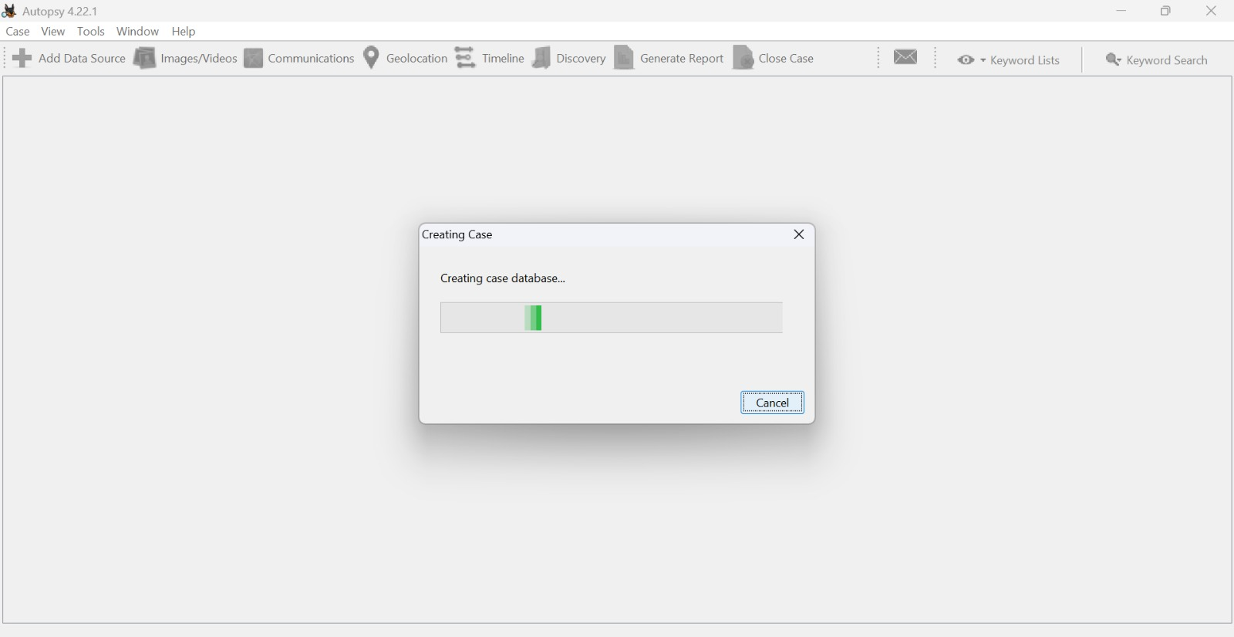

A forensic image is an exact bit-by-bit copy of a storage device. It preserves all data, including deleted and hidden files, ensuring integrity during analysis.

File System Analysis
    - Examined file directories and structure.
    - Identified recently accessed files and suspicious content.

Recovery of Deleted Files
    - Used Autopsy’s file recovery feature.
    - Recovered deleted files from unallocated space.

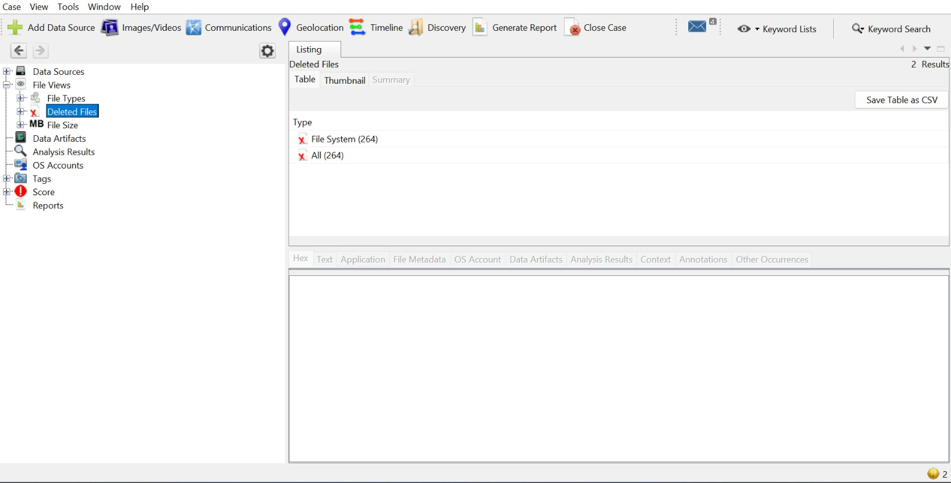

Web Activity Analysis
    - Analyzed browser artifacts including:
    - History
    - Downloads
    - Cookies
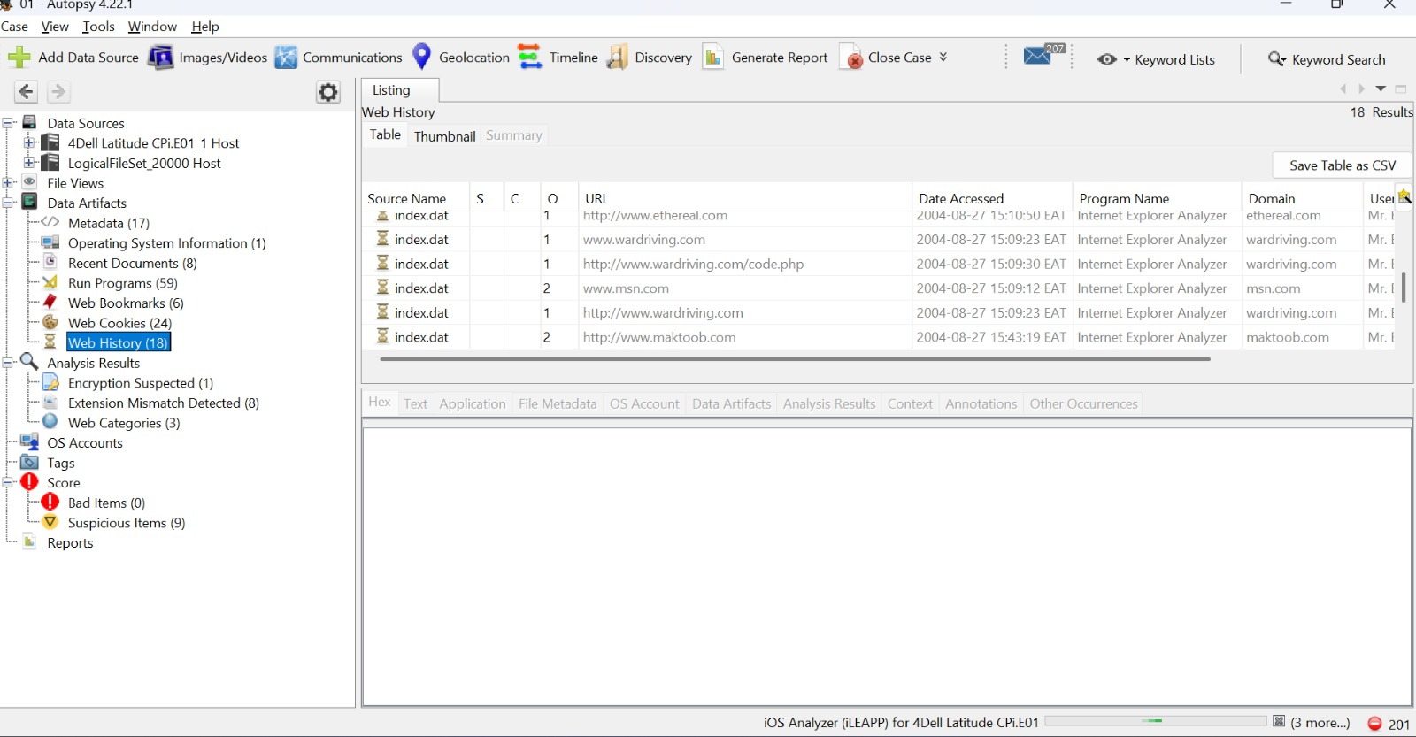

Keyword Search and Filtering
    - Searched for keywords such as:
    - "password"
    - "confidential"
    - 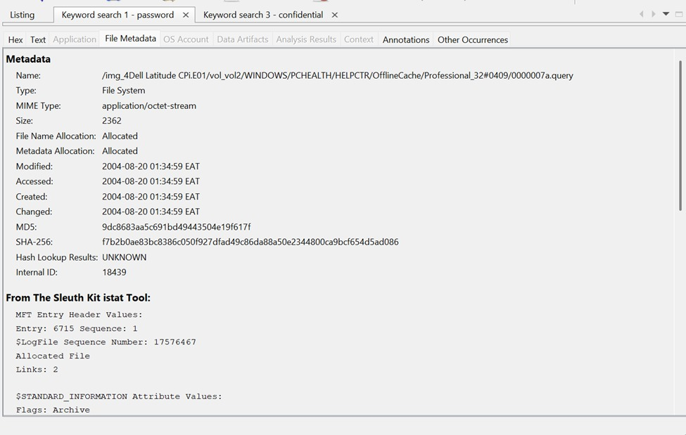

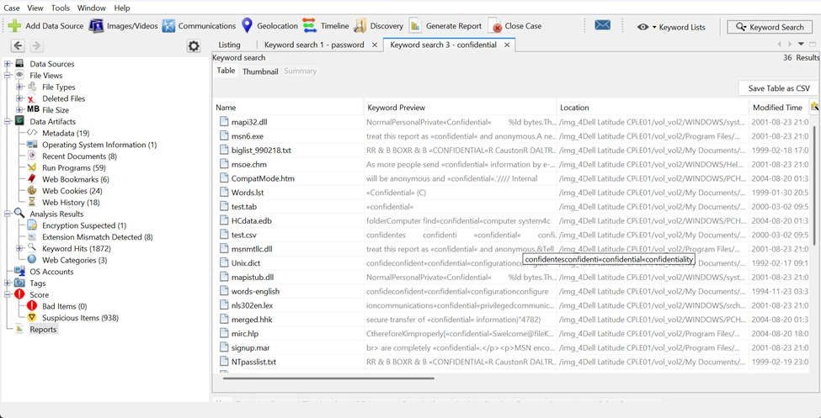

Timeline Analysis
    - Used timeline view to track user activities over time.

Reporting
    - Generated a forensic report using Autopsy’s reporting feature.

FINDINGS (WITH SCREENSHOTS)

Installation and Setup
Autopsy was successfully installed and launched. A new case was created.
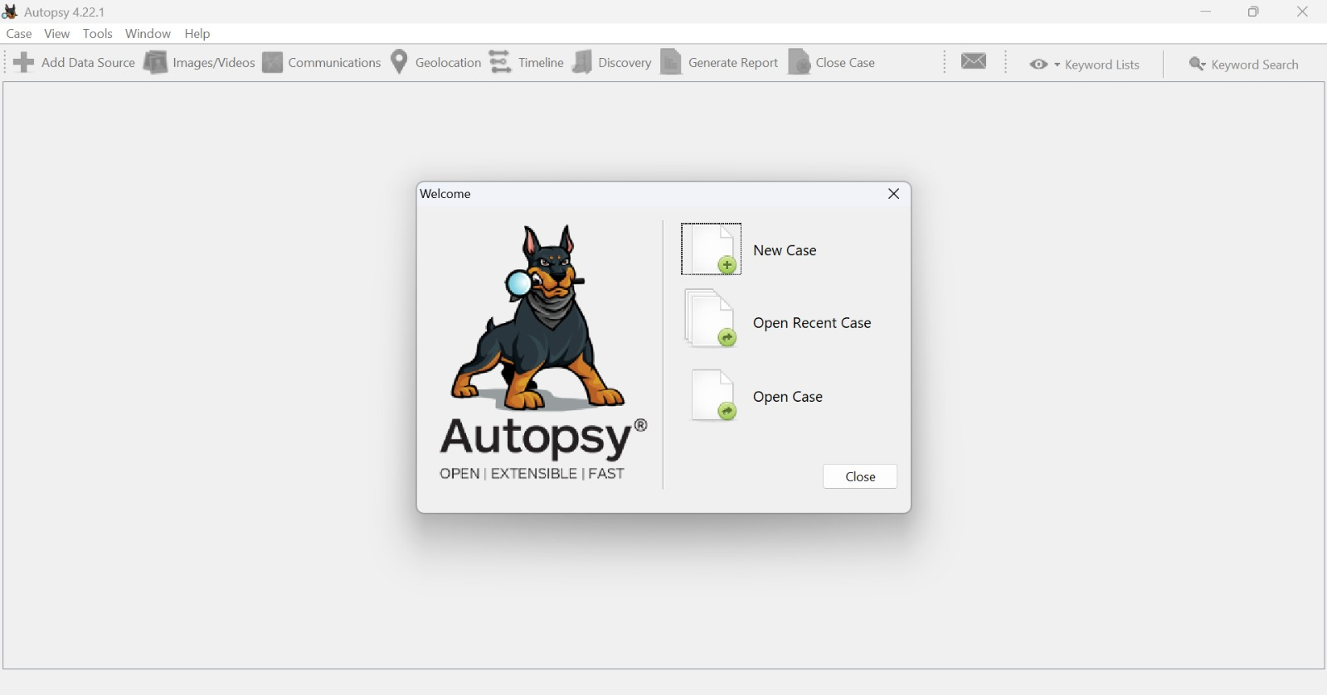

Case Creation and Evidence Loading
The disk image was successfully loaded into Autopsy.
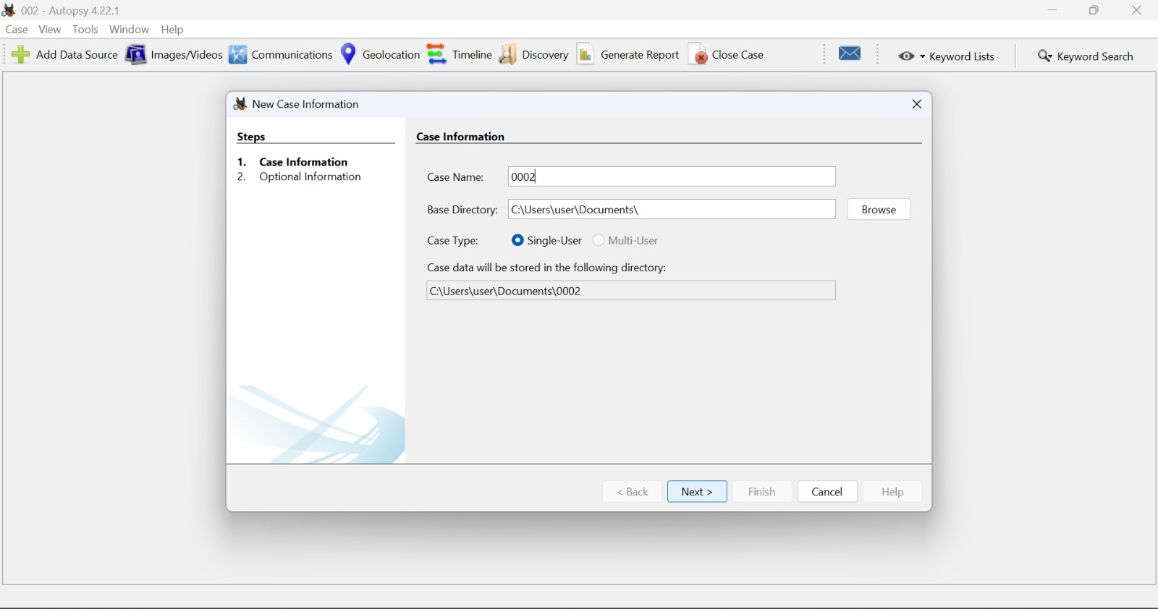

File System Analysis
    - Several files were identified in the Documents and Downloads folders.
    - Recently accessed files included documents and images.

Recovery of Deleted Files
Recovered deleted files included: 1. Deleted document file (important report) 2. Deleted image file 3. Deleted text file containing sensitive information



Web Activity Analysis
    - Browser history showed visits to multiple websites.
    - Downloads included documents and media files.
    - Cookies revealed user-browsing patterns.
    - 

Keyword Search and Filtering
Search results for keywords revealed: - Files containing the word “password” - Documents labeled “confidential”
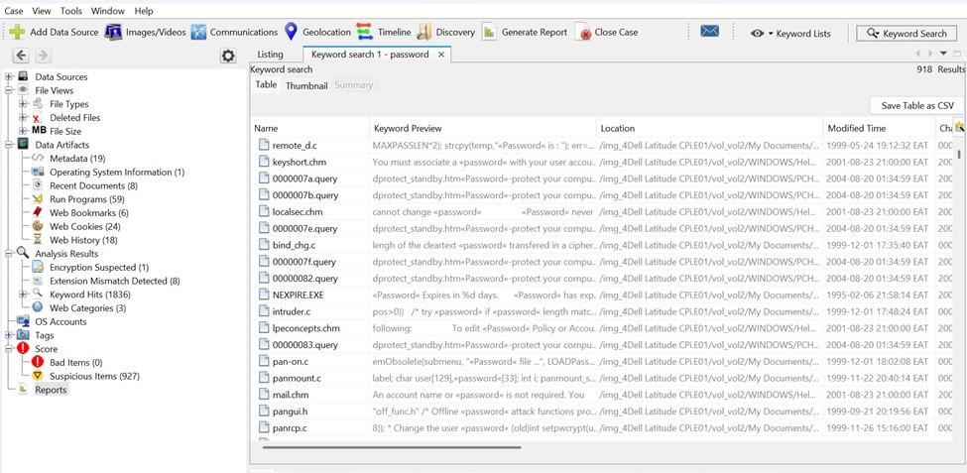

Timeline Analysis
Timeline analysis showed: - File creation and modification times - Sequence of user activities
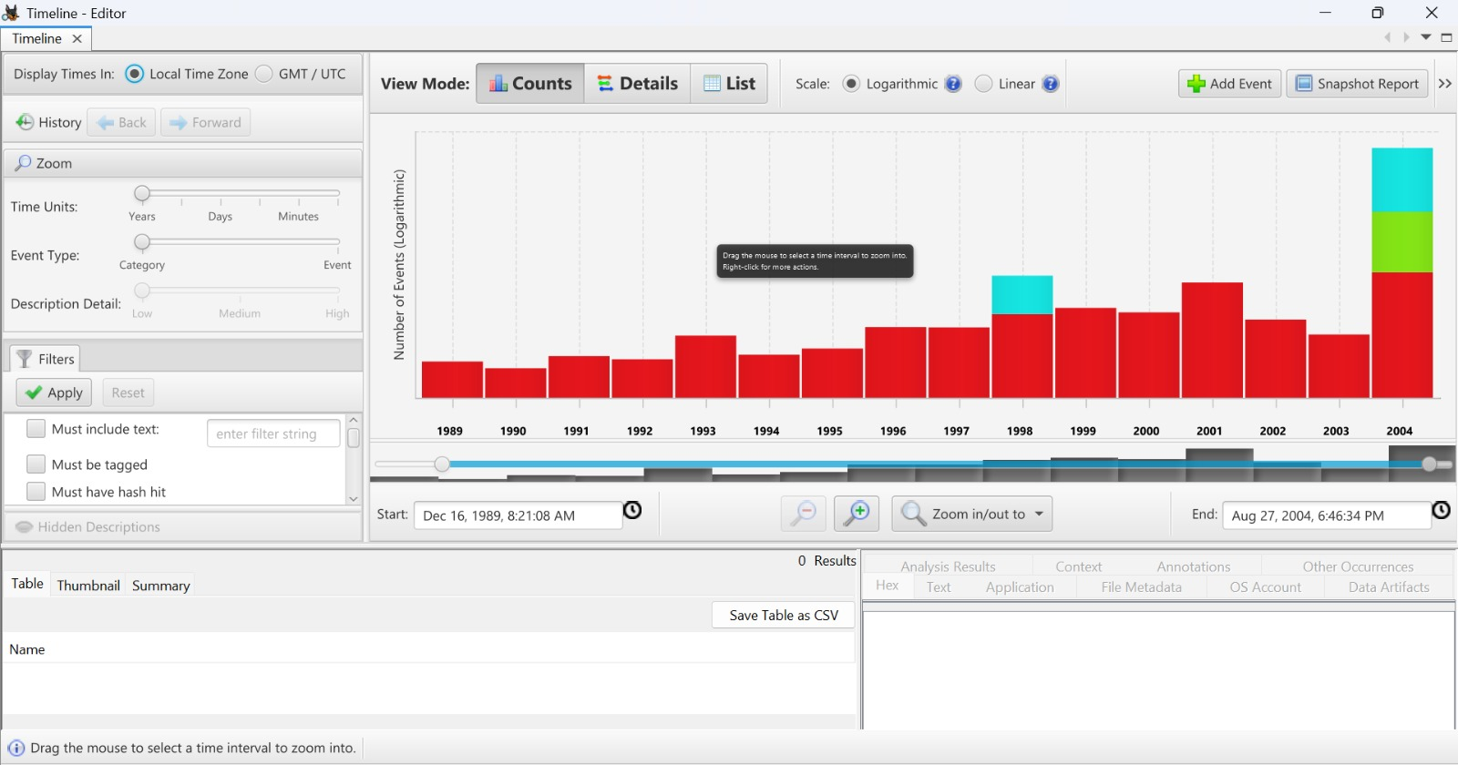

Reporting
A forensic report was generated and exported successfully.

ANALYSIS
The investigation revealed significant user activity within the system. The presence of deleted files indicates attempts to hide information. Recovery of these files demonstrates the effectiveness of digital forensic tools.

Web activity analysis provided insight into user behavior, including visited websites and downloaded files. Keyword searches helped identify sensitive data, which could be relevant in an investigation.

Timeline analysis allowed reconstruction of events, helping to understand the sequence of actions performed by the user.

Overall, Autopsy proved to be an effective tool for digital forensic investigation.

CONCLUSION
The digital forensic investigation was successfully conducted using Autopsy. The tool enabled the analysis of a disk image, recovery of deleted files, and examination of user activity.

The findings highlight the importance of digital forensics in uncovering hidden and deleted information. Proper forensic procedures ensure data integrity and reliability of evidence.

This assignment provided practical knowledge and skills in digital forensic investigation, which are essential in addressing cyber-related crimes.

REFERENCES

- Autopsy Official Documentation
- Digital Forensics Lecture Notes
- Cybersecurity Fundamentals Materials

